Prerequisites
Need to have admin rights on your environment (to install required modules)
PowerShell 5?7?
Node.js?
Xrm admin module
Xrm other module?
Pac CLI
Git
VSCode
GitHub Copilot
Python SDK?
//TODO create a new VM to test end-to-end
ADO MCP?

Quote:
an intelligent human with any of these models is more capable than something like Opus 4.7 on its own (see the detailed findings).

Overview
Black box building using Copilot Studio and app builder or within M365
MCP Server
Power Platform and Dataverse Skills
What is the different between each one and when to use which one
Or Hyper automation – Coding agents
No a black box, but point by point agentic development
Because we are public sector and we know what we want.

Introduction
Boundary of MDA and what else we are customizing (e.g. JS, Plugins, Power Automate, but not Canvas, and not Portals is grey area.

Use case
We are Zava, a public sector workplace health and safety regulator. Our role is to help ensure that people return home from work healthy and safe, and to hold organisations accountable when they fail to manage workplace risk.
We receive notifications via from the public through manual channels such as emails, letters, or phone call where organizations notify us on an incident that took place at work. We have a responsibility to respond go incidents, especially urgent one where a severe injury or fatality occurred.
Once we receive an application, we triage them and dispatch a team to investigate.
Our COO noticed that we spend too much time figuring out what is happening before we respond to an incident and our triage processes are slow as well. We need to automate the process.

Create a page that retrieves the top 10 customers ordered by name and colour code their city

Lab 0 – Setting up your environment
Clone the repository PPCC26 repository
https://github.com/ramimounla/PPCC26Alpha2.git
If you have PowerShell 7 (core) installed, ensure that your VSCode leverages

Lab 1 – Table and Columns
In this lab, you will use schema creation agents to automate the creation of a Dataverse table and its associated columns. The agents will load information from a provided data dictionary, interpret the schema definitions, and generate the required Dataverse artifacts. By the end of the exercise, you will have a fully configured table structure created through natural language instructions rather than manual configuration.

Prerequisites
- PowerShell 5.1
- GitHub Copilot

Steps
- Start your GitHub Copilot chat window (Ctrl + Alt + I) or (⌘ + Control + I)
- (❗important) Make sure to select the Create Dataverse Tables agent
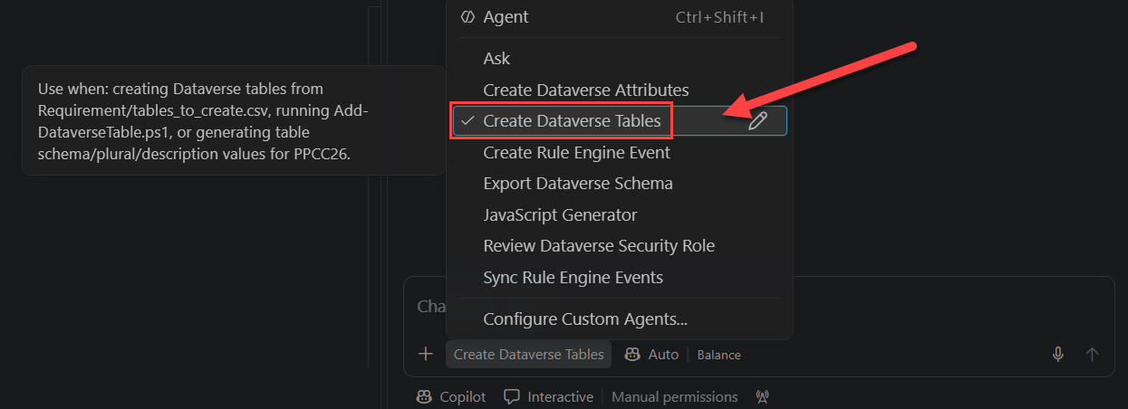
- Type the following prompt
Follow your prompt and create the new table PPCC Request as per the csv file. Don't deviate from the prompt's instructions.
- Once the command is completed, verify that the table has been created in Dataverse.
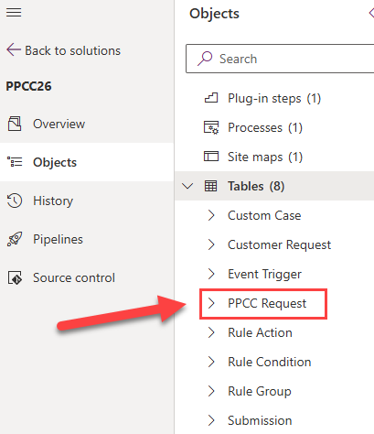
- (❗important) Switch to the Create Dataverse Attributes agent
- Type the following prompt
Follow your prompt and create the attributes for the ppcc_ppccrequest table as per the csv file. Don't deviate from the prompt's instructions
- Verify that the attributes have been created correctly.

Lab 2 - Update the forms / views / app using Skills
In this example, the requirement is to make additional fields visible and mandatory when the Type field is set to Other. The user provides the requirement in plain English, and the agent interprets the request, identifies the relevant fields and controls, retrieves the required metadata from the solution, and applies the appropriate utility. This removes the need for developers to manually analyse the schema, locate the relevant components, and implement the logic themselves, resulting in a faster and more efficient development experience.

Prerequisites
- GitHub Copilot
- pac CLI (optional)

Steps
- (❗important) Switch to the Form Editor agent
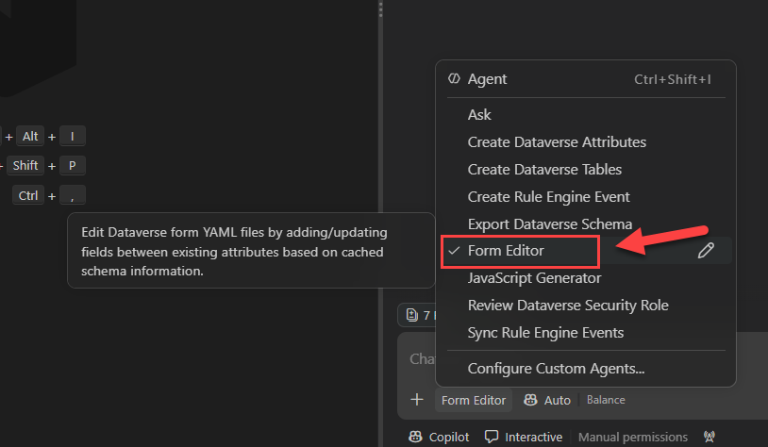
- Type the following prompt
- Follow your instructions and update the Submission’s Portal form by adding the Description field between the "Fatality" and "Date of event" fields.
- Verify that the form was updated with a the Description field in the middle.
- In your repository’s root folder execute this command
pac solution pack --folder .\Solution --zipfile ppcc26_unmanaged.zip --packageType Unmanaged
- (optional) Import the solution into your environment

Lab 3 – Portal forms update

Lab 4 – Low code Power Automate
On submit of a application – assign to the correct queue?
Prerequisites

Lab 5 – Customization front-end using libraries
This section focuses on agents that can build and configure front-end JavaScript customisations. The goal is to establish a set of reusable libraries that address common business requirements, eliminating the need to repeatedly implement the same logic across different solutions. By promoting reusability and standardisation, these libraries accelerate development, improve consistency, and reduce ongoing maintenance effort.
These frameworks are designed to be AI-ready, meaning that the agents are aware of their capabilities and can leverage them when implementing a solution. Rather than generating custom code from scratch, the agent evaluates the requirement, determines whether an existing utility can satisfy the need, and automatically configures and wires the appropriate scripts into the application.
In this example, the requirement is to make additional fields visible and mandatory when the Type field is set to Other. The user provides the requirement in plain English, and the agent interprets the request, identifies the relevant fields and controls, retrieves the required metadata from the solution, and applies the appropriate utility. This removes the need for developers to manually analyse the schema, locate the relevant components, and implement the logic themselves, resulting in a faster and more efficient development experience.

Prerequisites
- GitHub Copilot

Steps
- (❗important) Switch to the JavaScript Generator agent
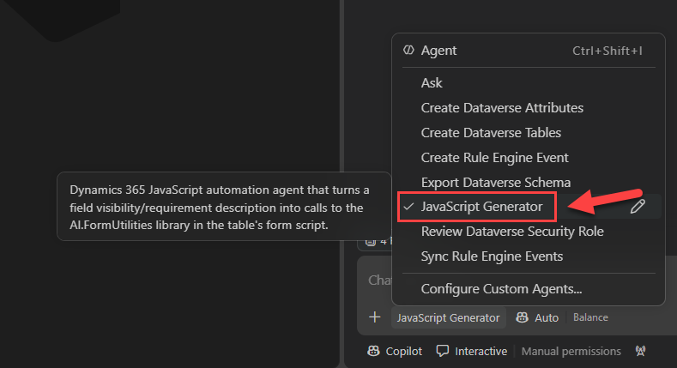
- Type the following prompt
Follow your prompt and add logic to the Custom Case form to make the Other field visible and mandatory when the Type field is set to Other. Reuse existing solution utilities where possible and avoid creating custom logic if an appropriate framework component already exists.
- Verify that your agent has update the ppcc_customcase.js web resource with the following details.

AI.FormUtilities.setupFieldVisibility(formContext, "ppcc_type", "ppcc_other", 100000004);
AI.FormUtilities.setupConditionalRequirement(formContext, "ppcc_type", "ppcc_other", 100000004);

- (optional) deploy the web resource with spkl ~\spkl\ deploy-webresources.bat
- (optional) test the changes in your custom case entity (might need to clear your cash and refresh your page).

Lab 6 – Customization back-end using AI-ready accelerator
This lab focuses on our custom-built AI-ready accelerator, which enables the execution of server-side business logic through data-driven instructions. Rather than developing and deploying plugins from scratch, the accelerator allows behaviour to be defined and configured dynamically, significantly reducing development effort, deployment complexity, and maintenance overhead.
During this exercise, you will use the accelerator to implement server-side logic by defining instructions and configuration data. This approach demonstrates how business rules and automation can be driven through metadata, enabling faster delivery, greater flexibility, and a more scalable development model compared to traditional plugin-based implementations.

Prerequisites
- PowerShell 5.1
- GitHub Copilot

Steps
- (❗important) Switch the Create Rule Engine Event agent
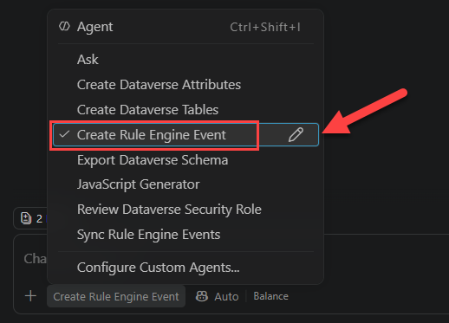
- Type the following prompt
Follow your prompt and create a new event that triggers on create of a custom case. If the type is set to fatality, then set the priority to high.
- Verify that your agent has created an event JSON file under Requirements/events
- (❗important) Switch to the Sync Rule Engine Events agent
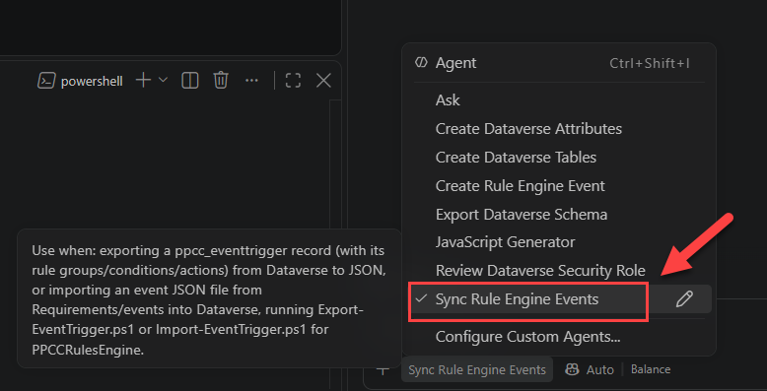
- Type the following prompt
Upload the customcase-fatality-priority.json
- Go to your Model Driven App and create a new Custom Case with a type of fatality and save it. Ensure that the priority has been updated to High.
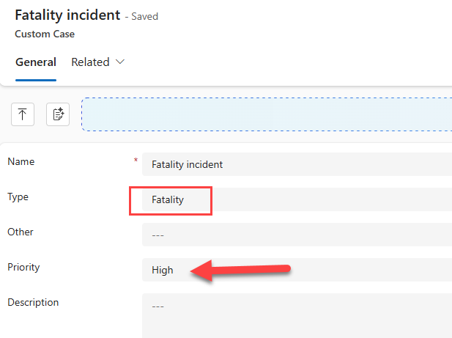

Lab 7 – Security Review
This lab focuses on a static analysis agent that reviews implemented security rules and validates them against a defined set of requirements. The purpose of this exercise is to demonstrate an agent's ability to analyze content, assess compliance with expected behavior, and identify gaps or inconsistencies.
During this lab, you will observe how an agent can evaluate security configurations, compare them to documented requirements, and provide feedback on areas that may require attention. While this example is centered on security, the same agentic pattern can be applied to a wide range of governance, compliance, and code quality assurance scenarios where implemented solutions need to be validated against established standards or business requirements.

Prerequisites
- GitHub Copilot

Steps
- (❗important) Switch to the Review Dataverse Security Role agent
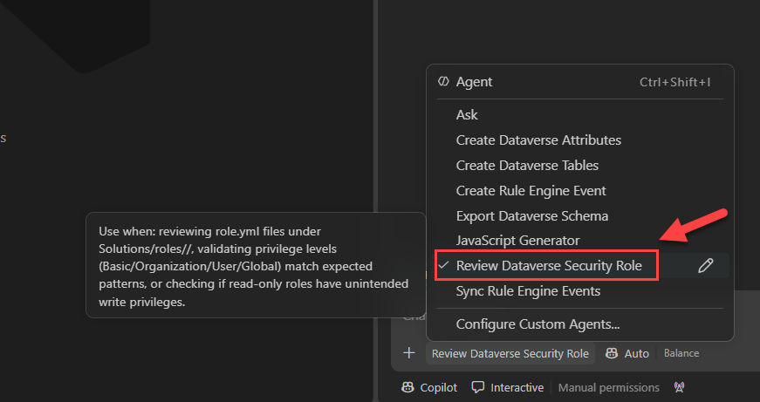

- Type the following prompt
Validate that the Customer Read-Only security role grants read-only access and does not permit create, update, delete, append, append-to, assign, or share privileges.

Lab 8 – Testing using Playwright MCP
- Inner loop
- Building reusable frameworks such as gerkin
- Unit testing and speed of testing

Lab 9 – Skill to write Business Skills Work IQ

Lab 10 – Skill to deploy

Lab 11 – Python SDK?

NVIDIA CEO Jensen Huang famously said:
❝ You're not going to lose your job to AI, but you're going to lose your job to someone who uses AI. ❞
Many industry experts believe that agentic development will become mainstream as early as Q1 2027. The same is true for the Power Platform. The good news? There's still time to get ahead of the curve and build the skills that will set you apart.
I'm excited to be speaking at the Power Platform Community Conference 2026 (#PPCC26), where I'll be delivering a full-day workshop and two conference sessions focused on the future of AI-powered development on the Power Platform.
🚀 Create Your Own Agentic Squad to Build Power Apps
A hands-on, end-to-end workshop that demonstrates how AI agents can accelerate every stage of the Power Platform application lifecycle.
We'll cover:
- Schema and UI configuration
- Low-code development
- Pro-code customisation
- Power Pages customisation
- Security configuration
- Testing and quality assurance
- Deployment and release management
- And much more
Most importantly, you'll get practical, guided lab exercises throughout the day so you can apply these concepts immediately.
🔗 Workshop: https://powerplatformconf.com/workshops/Create-Your-Own-Agentic-Squad-to-Build-Power-Apps

Conference Sessions
✅ Code Meets Low Code: Building with Copilot Managed Runtime and Power Platform https://powerplatformconf.com/sessions/Code-Meets-Low-Code%3A-Building-with-Copilot-Managed-Runtime-and-Power-Platform
✅ Power Platform Agentic Testing https://powerplatformconf.com/sessions/Power-Platform-Agentic-Testing
Looking forward to seeing everyone at PPCC26!
#PPCC26 #PowerPlatform #CopilotStudio #AgenticAI #PowerApps #PowerPlatformConference #MVPBuzz #MSDyn365

To ensure a smooth start to the workshop and to avoid delays caused by software installations or permission issues, please ensure the following prerequisites are in place before the day.
Workshop Access
On the day of the workshop, each participant will be provided with:
- A dedicated username and password
- Access to an individual Dataverse environment for use throughout the hands-on exercises
These details will be distributed during the workshop.
Prerequisites
- Local administrator rights on your laptop
- Latest version of Node.js
- Latest version of PAC CLI
- Latest version of Dataverse CLI
- Latest version of Visual Studio Code (VS Code)
- Visual Studio
- Legacy PowerShell 5.1
- Latest version of PowerShell 7
- Latest version of Python
- Git tools
- [important] GitHub Copilot licence with sufficient token credits for a full day of workshop activities and prompting exercises

